**UI Prototype**

**Sign In && Sign Up:**

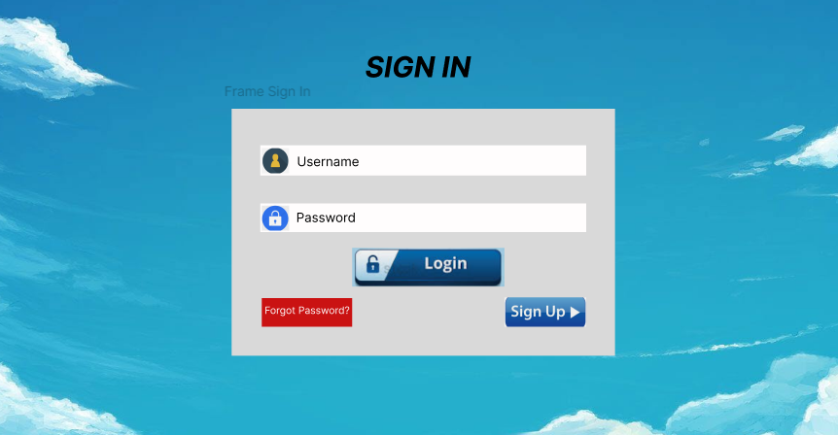

Description:

On the login screen, there will be 3 items that can be clicked to trigger a new page:

* Login: after filling in the account information and password

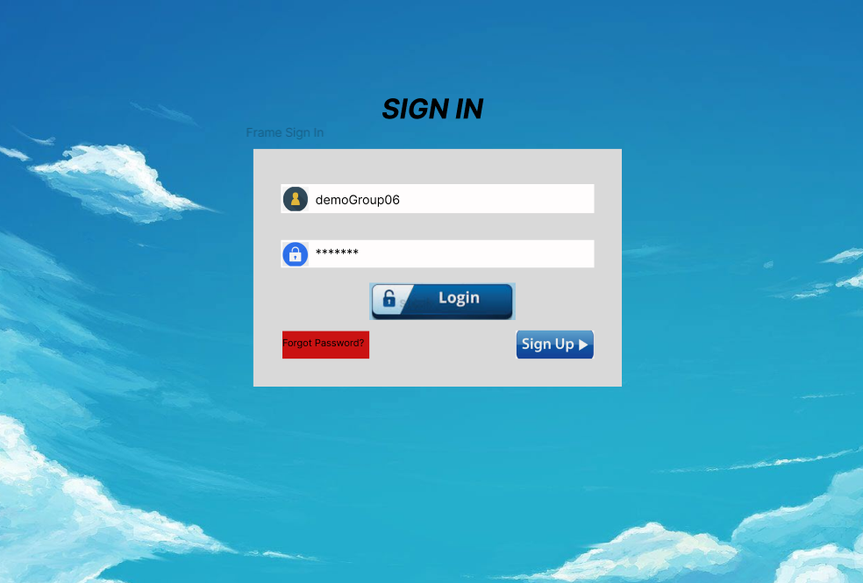

* + Here users can click on the Login button to proceed with logging into the system.
    - User successfully logged in:

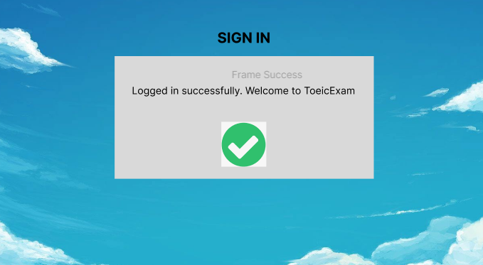

* + - User entered incorrect login information:

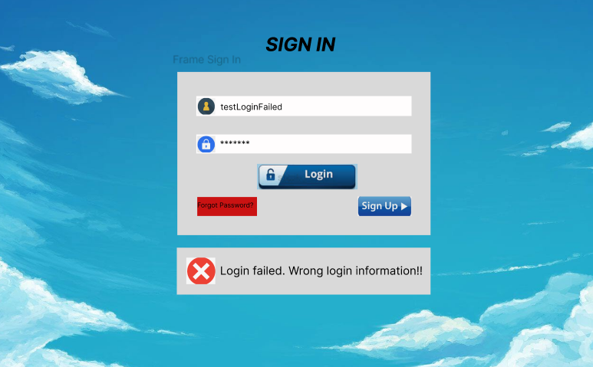

* Forgot Password?
  + First, the system will display a square for the user to enter the account name and search.

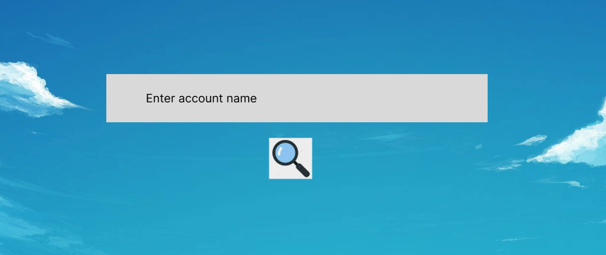

* + If the search is successful, the user will enter the registered phone number.

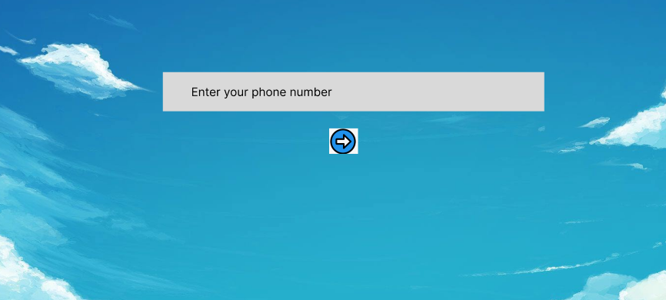

* + - Here. The user will be sent an OTP to the phone number. Enter the OTP and change the new password.

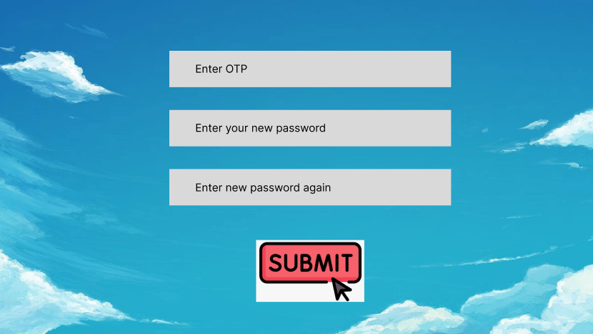

* + - If successful, the user will be returned to the main screen. Here. Users can enter the newly changed account and password to access the website.
    - If it fails, the system will notify that the user has not entered the correct OTP information or the password entered does not match.

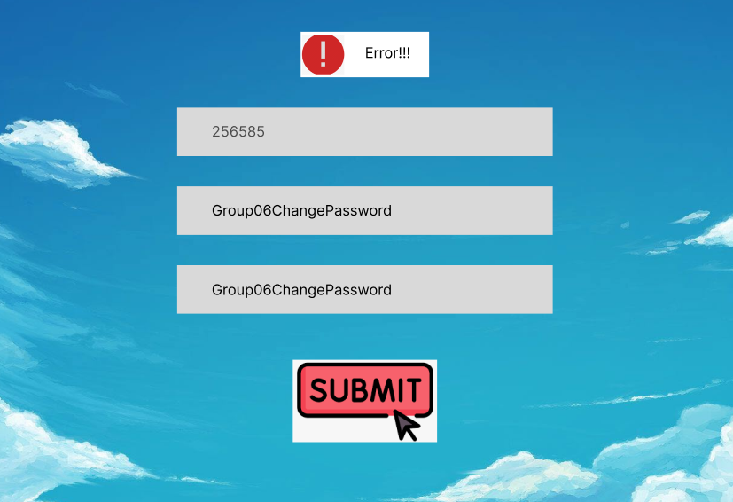

* + If the search fails, the system will say the account is not available.

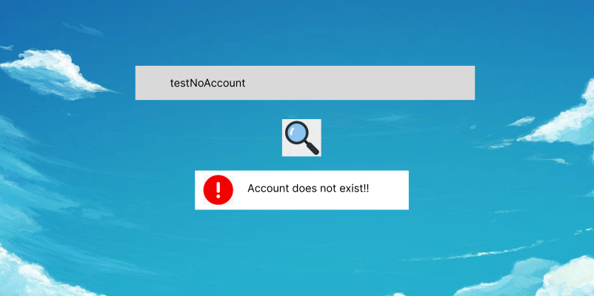

* Sign Up
  + Users will be asked to enter information including:
    - Account name
    - Password (password will be asked to re-enter once to confirm that the user entered the correct password)
    - Phone number

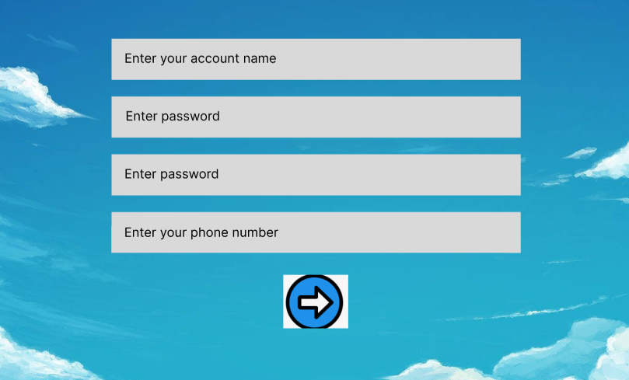

* + If the account or phone number is already in the system's data list. The system will report an error and ask the user to choose another name or phone number to register.
    - Register for an existing account:

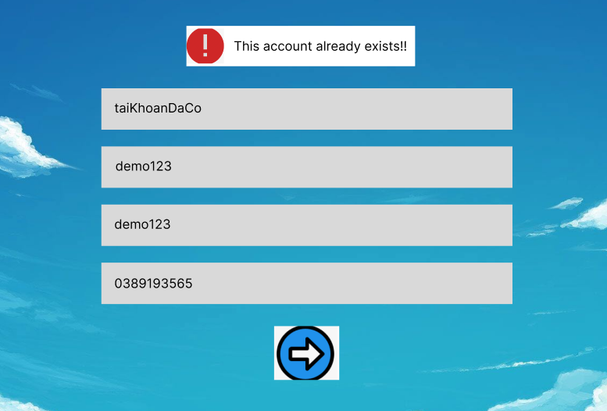

* + - Register with the phone number used to register for another account before:

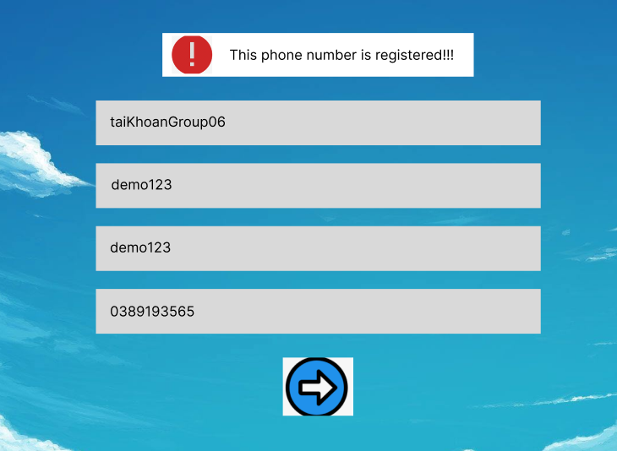

* + Then the user clicks on the arrow icon. The system will verify and send the OTP code to the registered phone number.

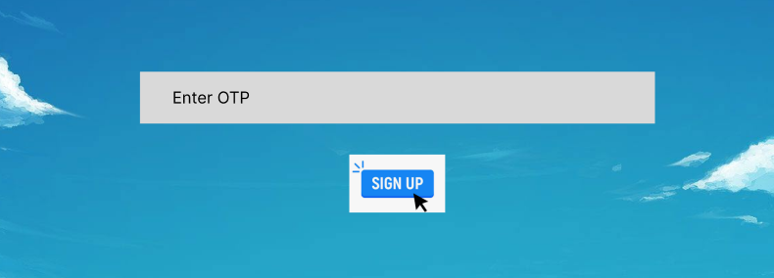

* + Sign up Success. The user will be returned to the login screen and begin to log in to the newly created account.

**Home page:**

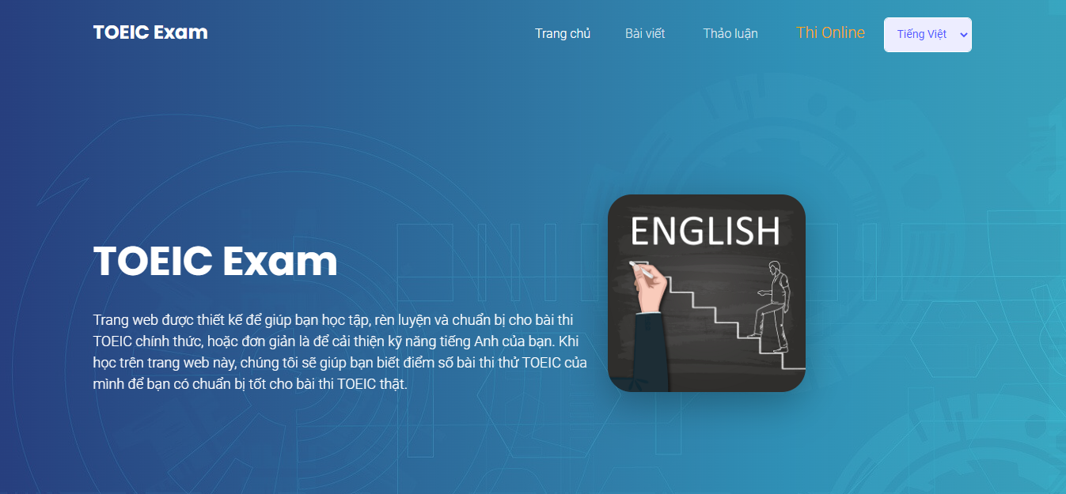

*Home page 1*



*Home page 2*

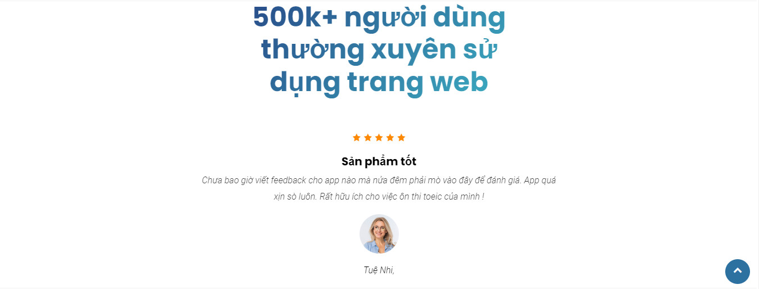

*Home page 3*

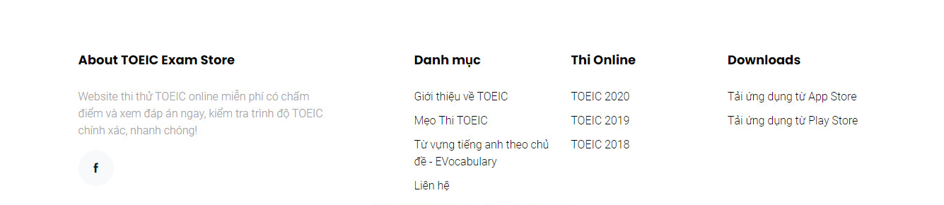

*Home page 4*

Description:

* When users enter the website to access the site, the screen will display as shown "homepage 1", including the web logo bar, the navigation menu bar to other parts of the web, if the user pulls down to the bottom then then Will display the images from "Home 2" to "Home 4" including: web page description, web comment, contact information of the web
* When users click on the "Trang chủ" section in the navigation bar, it will move to the picture "homepage 1"
* When the user clicks on the "Bài viết" section in the navigation bar, it will move to the following picture:

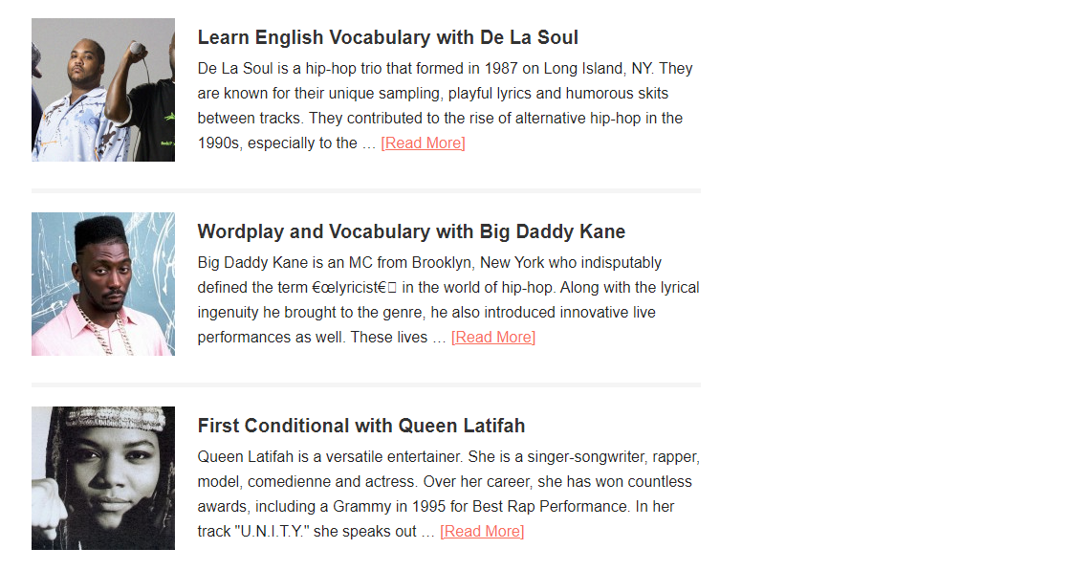

*For example, when clicking on the article on the navigation bar*

* When the user clicks on the "Thảo luận" section in the navigation bar, it will move to the following picture:

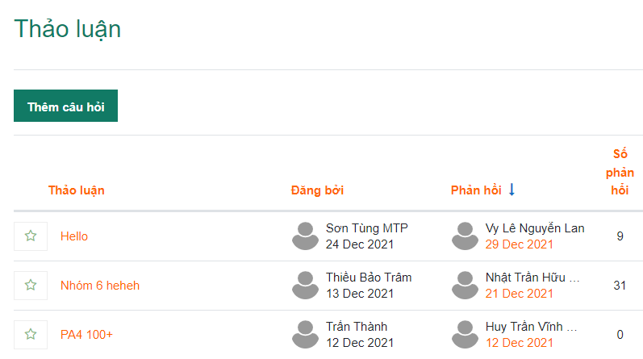

*For example, when clicking on the discussion on the navigation bar*

* When the user clicks on the "Thi online" section in the navigation bar, it will move to the following picture:

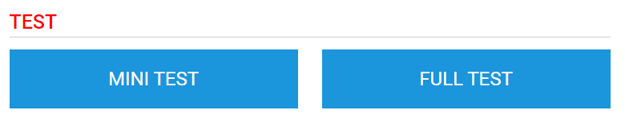

*For example, when clicking on the online exam*

* Người dùng sẽ chọn 1 trong 2 phần:
  + Nếu chọn Mini test thì màn hình sẽ hiển thị như sau:

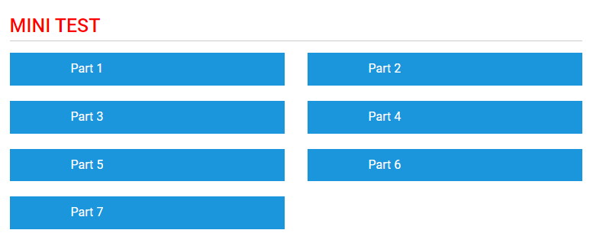

*For example when clicking on the mini test*

Users click on 1 of 7 parts to do, when clicking on Part 1 or Part 7, they will display the same as follows: (Details when clicking on will be presented below)

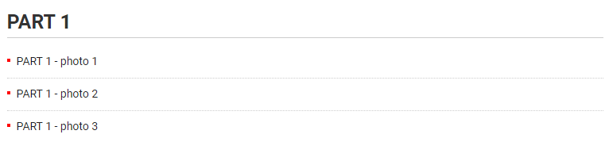

*For example when clicking on parts*

* If you choose full test, the screen will display as follows:

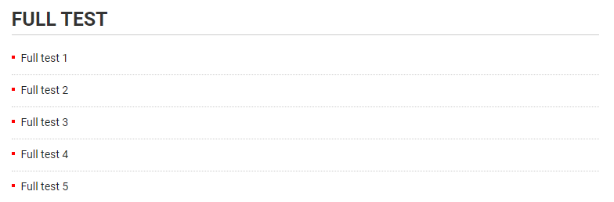

*For example when clicking on Full Test*

* Users click 1 of the full tests to do

**Part 1 Screen:**

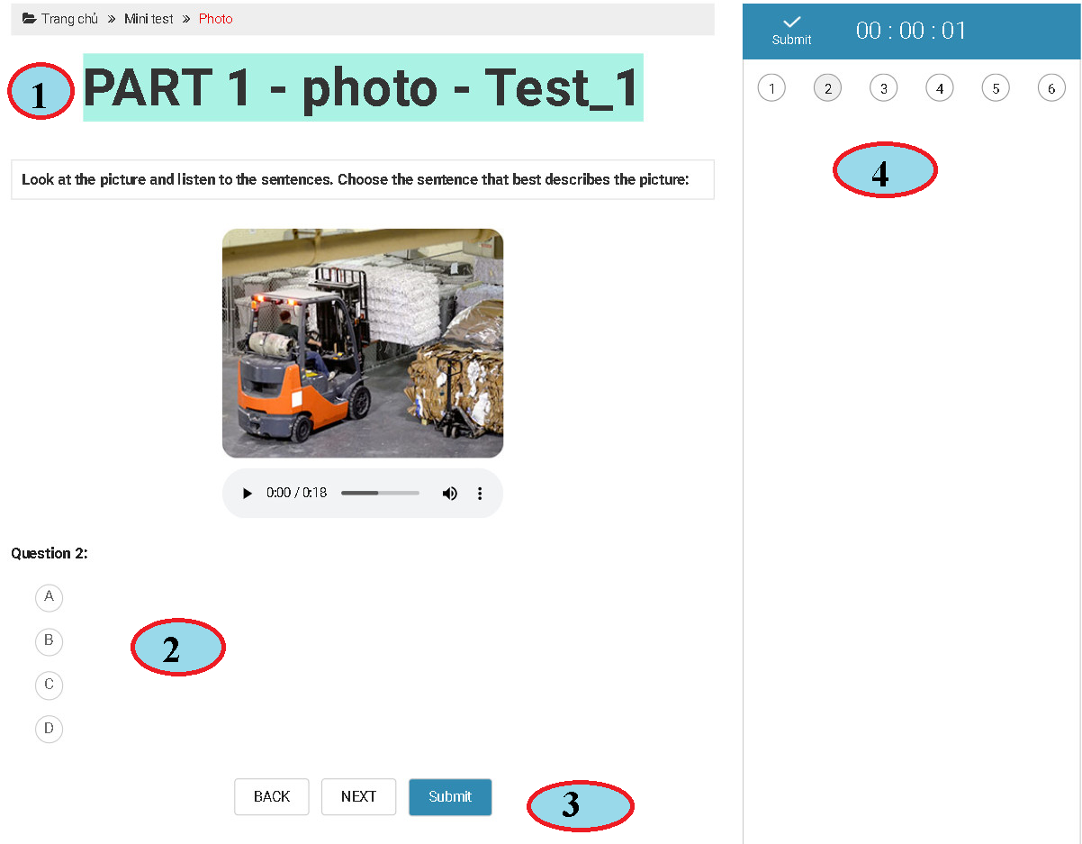

Description:

* When the user clicks on any part 1 test, it will display as above, including:
* Area 1:
  + Title part: Part 1 - Photo test 1
  + The Minitest button returns to the homepage
* Area 2:
  + Audio section to listen to users click to listen to English speaking
  + The user finished listening to select the answer of that question, the answer there was black
* Area 3:
  + The Back button returns to the previous questions
  + The Next button moves to the next questions
  + Submit button to submit homework and automatic grading system
* Area 4:
  + Submit button to submit homework and automatic grading system
  + The meter counts down the test time, when the system is over, the system will automatically score

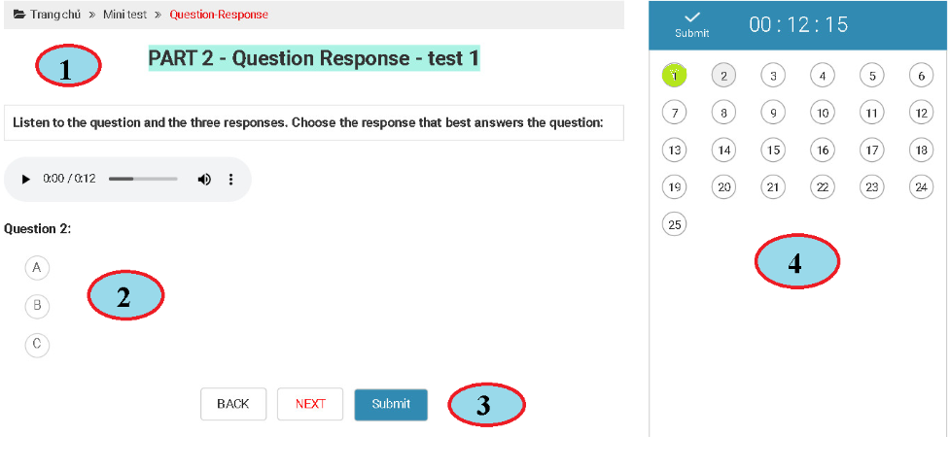

Description:

* When the user clicks on any test of PART 2, the interface will appear as above
* Area 1:
  + Title: PART 2 - Question Response - Test 1
  + Minitest button back to the previous page
  + The home button returns to the home page
* Area 2:
  + Audio section to listen to users click to listen to the spoken English section
  + After listening, the user chooses the answer to that question, the answer there is highlighted in black
* Area 3:
  + Back button to return to previous questions
  + The next button goes to the next questions
  + Submit button to submit work and automatic grading system
* Area 4:
  + Submit button to submit work and automatic grading system
  + Countdown timer, when the time is up, the system will automatically grade
  + When the user has finished selecting the answer to that question, the question number will be colored green
  + Screen after grading

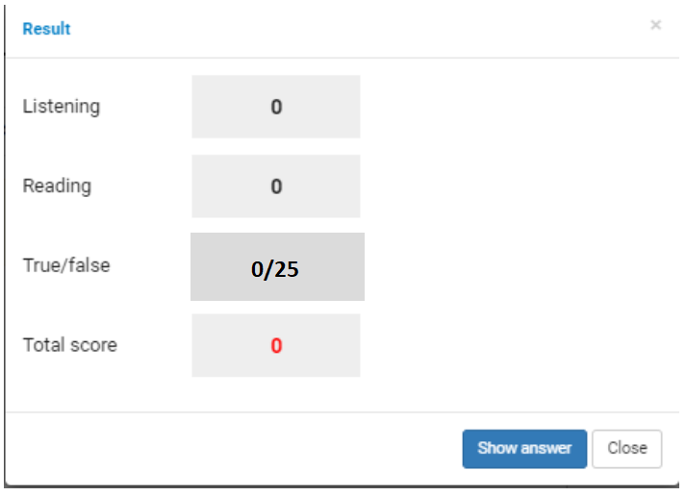

**Part 3 Screen:**

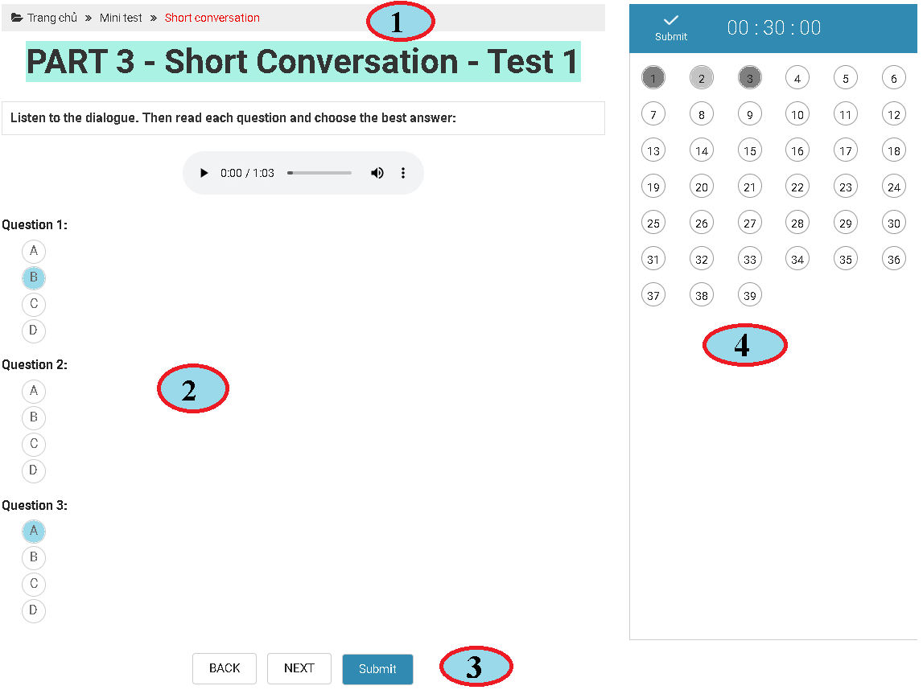Description:

* When the user clicks on any test of PART 3, the interface will appear as above
* Area 1:
  + Title: PART 3 - Short Conversation - Test 1
  + Minitest button back to the previous page
  + The home button returns to the home page
* Area 2
  + Audio section to listen to users click to listen to the spoken English section
  + After listening, the user chooses the answer of that question, the answer there is highlighted in black
* Area 3:
  + Back button to return to previous questions
  + The next button goes to next questions
  + Submit button to submit work and automatic grading system
* Area 4:
  + Submit button to submit work and automatic grading system
  + Countdown timer, when the time is up, the system will automatically grade
  + When the user has finished selecting the answer to that question, the question number will be colored green
  + Screen after grading

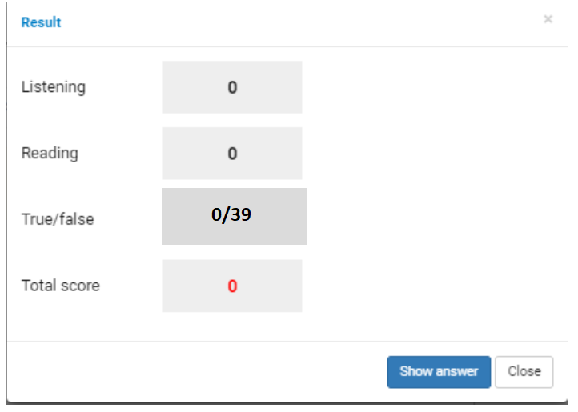

**Part 4 Screen:**

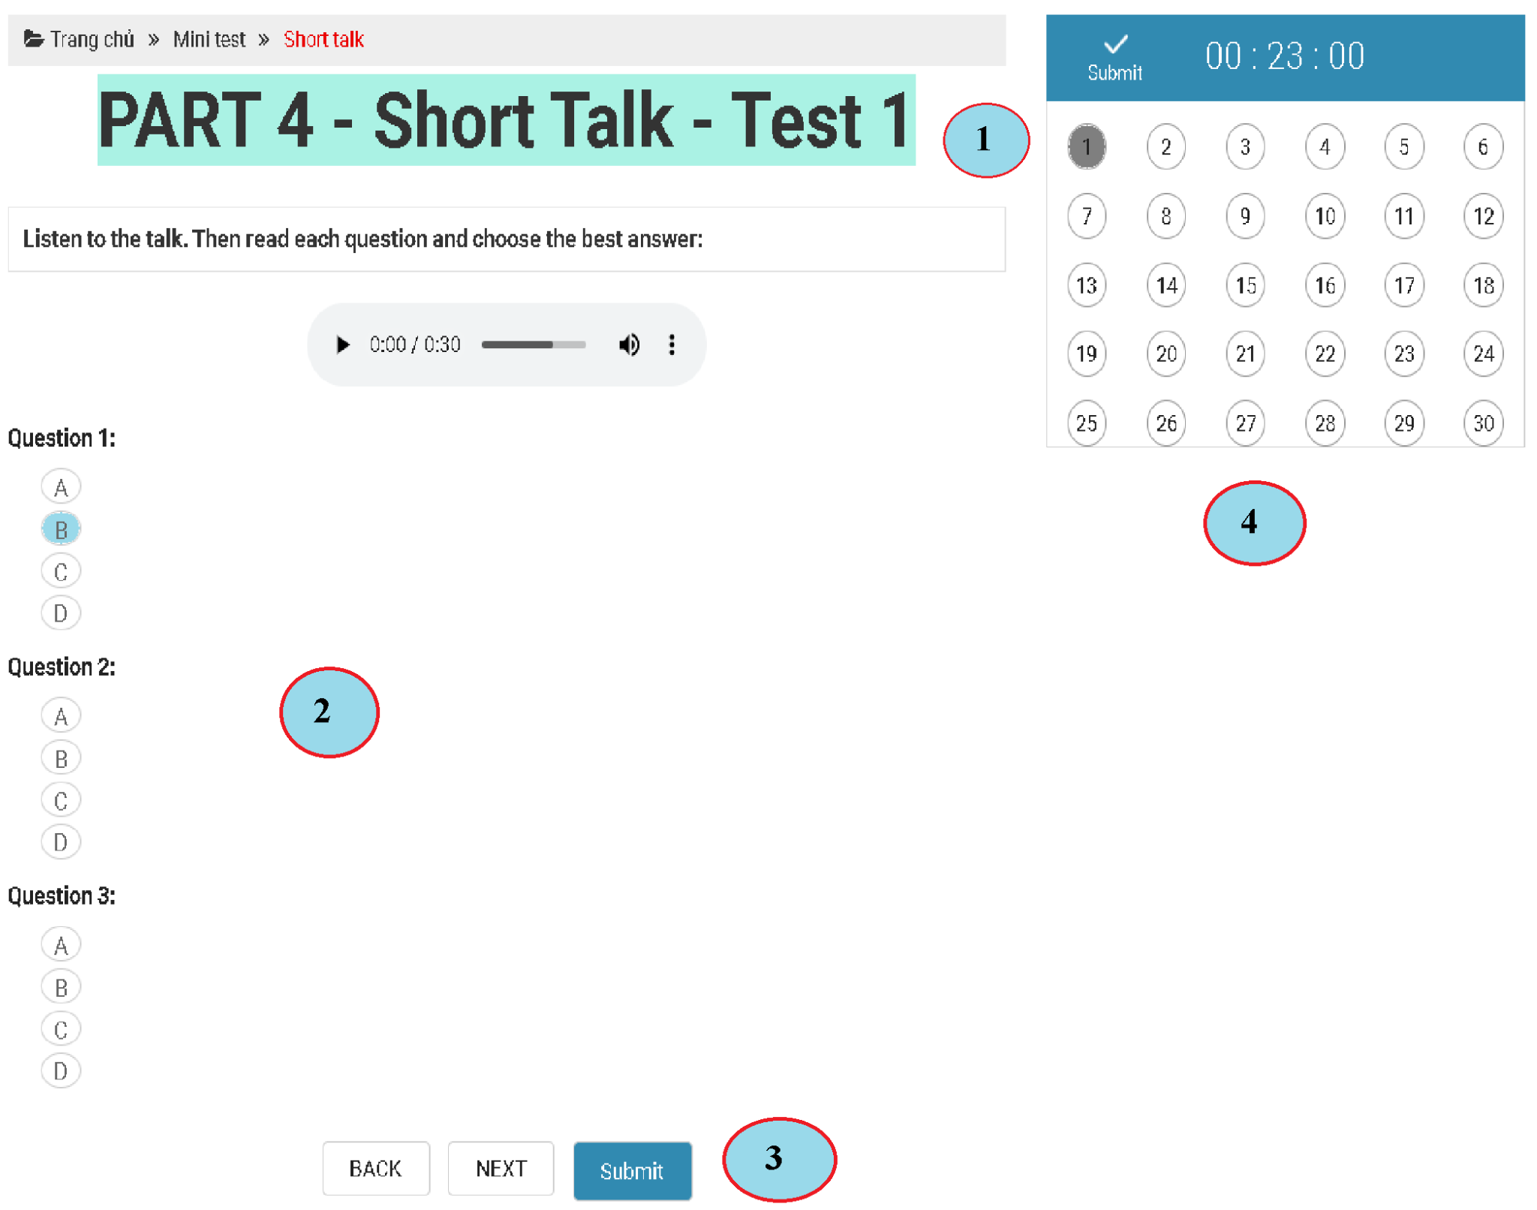

Description:

* When the user clicks on any test of PART 4, the interface will appear as above
  + Area 1:
  + Title: PART 4 - Short Talk - Test 1
  + Minitest button back to the previous page
  + The home button returns to the home page
* Area 2
  + Audio section to listen to users click to listen for about 30 seconds
  + Questions and 4 answers, users listen and answer
  + If the user answers the question, it will be highlighted in bold
* Area 3:
  + The back button goes back to the previous 3 sentences
  + The next button goes to the next 3 sentences
  + Press the submit button, the system will display points as shown below

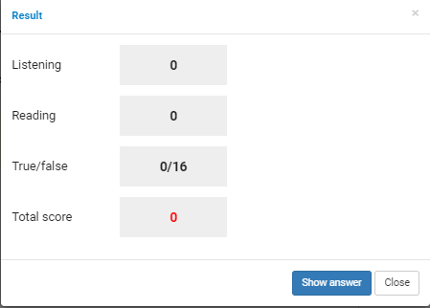

* Area 4:
  + Submit button for submission and grading system
  + Countdown timer to do the test for 23 minutes when the time is up, the system will score
  + If the user answers any question, that number box will be changed in color

**Part 5 Screen:**

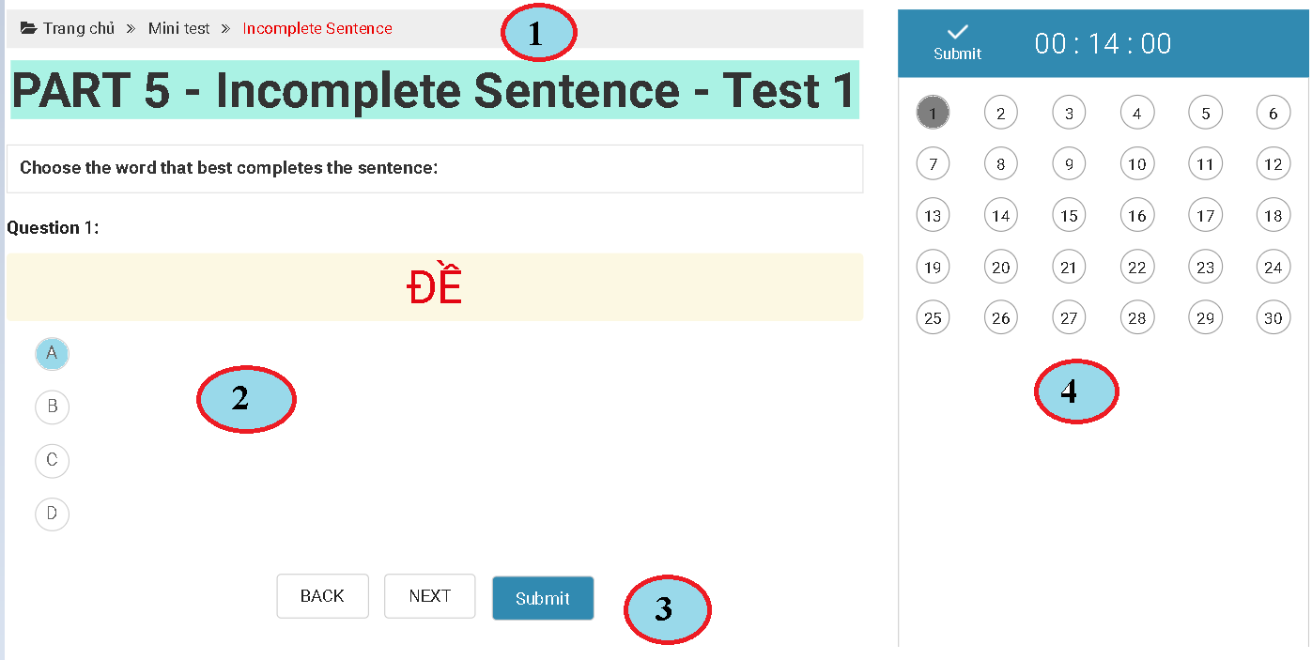

Description:

* When the user clicks on any test of PART 5, the interface will appear as above
* Area 1:
  + Part title: PART 5 - Incomplete Sentence - Test 1
  + Minitest button back to the previous page
  + The home button returns to the home page
* Area 2
  + The user section reads and chooses 4 answers below
  + If the user answers the question, it will be highlighted in bold
* Area 3:
  + The back button goes back to the previous sentence
  + The next button goes to the next sentence
  + Press the submit button, the system will display points as shown below



* Area 4:
  + Submit button for submission and grading system
  + A countdown timer for 14 minutes when the time is up, the system will score
  + If the user answers any question, that number box will be changed in color
  + Users can click on the sentence they want from 1 -> 30 to jump to

**Part 6 Screen:**

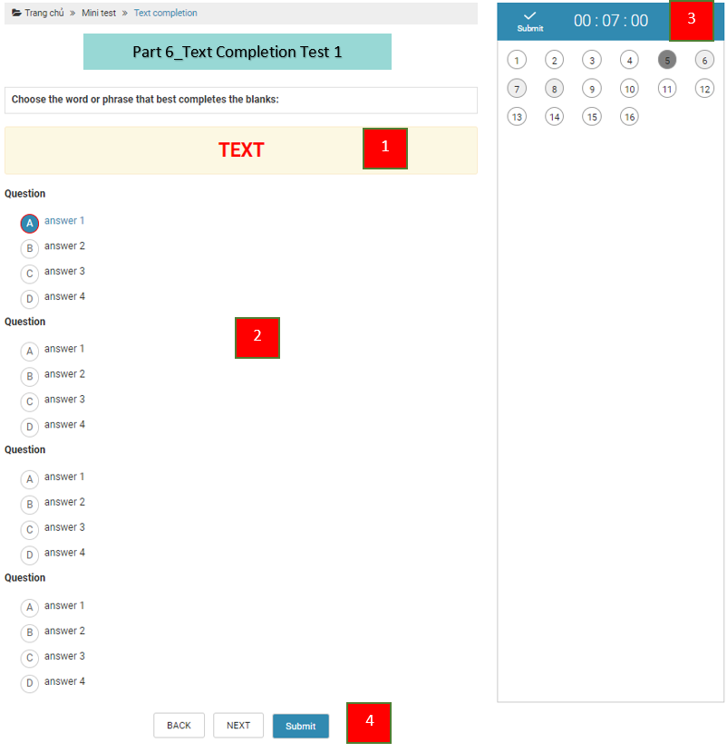

* Area 1:
  + Show exam content.
* Area 2:
  + Show questions.
  + Each question will have 4 answers (A, B, C, D) in this part 6, users will click on the answer to choose.
* Area 3:
  + Submit button: users click here to submit the article
    - After pressing submit, the scoreboard will appear



* + Time display frame
  + The box displays all the sentences in part 6, the one that has selected the answer will be red
* Area 4:
  + Submit button: users click here to submit articles
    - After pressing submit, the scoreboard will appear



* + Next button: to move to the next question screen
  + If the user has moved to the next question screen, there will be a back button to go back to the previous question

**Part 7 Screen:**

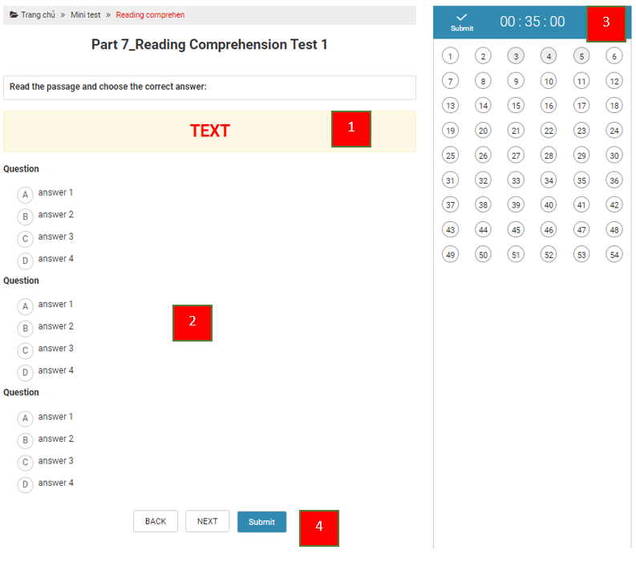

* Area 1:
  + Show exam content.
* Area 2:
  + Show questions.
  + Each question will have 4 answers (A, B, C, D) in this part 7, users will click on the answer to choose.
* Area 3:
  + Submit button: users click here to submit the article
    - After pressing submit, the scoreboard will appear

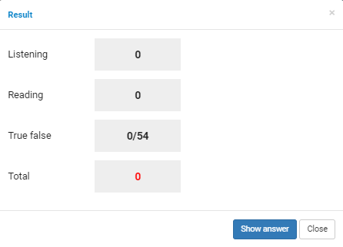

* + Time display frame
  + The box showing all the sentences in part 7, the sentence that has selected the answer will be red.
* Area 4:
  + Submit button: users click here to submit articles
    - After pressing submit, the scoreboard will appear



* + Next button: to move to the next question screen
  + If the user has moved to the next question screen, there will be a back button to go back to the previous question.